T128 GUIDE TO PACKING YOUR BIKE

A well-packed bike is a pleasure to ride. Yes, it might be a little heavier than usual, but that means you have more momentum when you’re up to speed! Here are five tips for packing well:

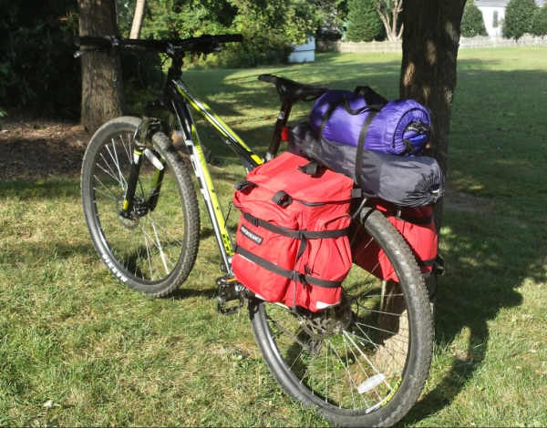
- Keep it light. Avoid taking unnecessary items or too much of necessary items. Will you really need two pairs of socks?
- Keep it tight. Secure all loose straps, cords, and equipment. Dangling straps could interfere with your wheels, breaks or chain, and might cause an accident. Items that fall off your bike might be lost for good by the time you realize they are gone.
- Keep it out of sight. Your equipment should fit entirely in your panniers, or other carrying bags like your tent bag. Not only do exposed items tempt thieves, but they could fall off your bike during a bumpy ride.
- Keep it low. To the maximum extent you can, put heavy things in the bottom of your panniers, and lighter items up top. This helps give you a lower center of gravity, which will be an advantage when riding trails.
- Keep it dry. Even if your panniers say they are waterproof, use plastic bags to line the inside of your panniers on rainy days. Similarly, wrap your tent and sleeping bag in plastic bags.

Will it fit? Yes!!
coffee pot knife/fork/spoon H2O jug sleeping bag tent
cup stove & fuel

ground mat

bike tools, pump, patches and spare tube

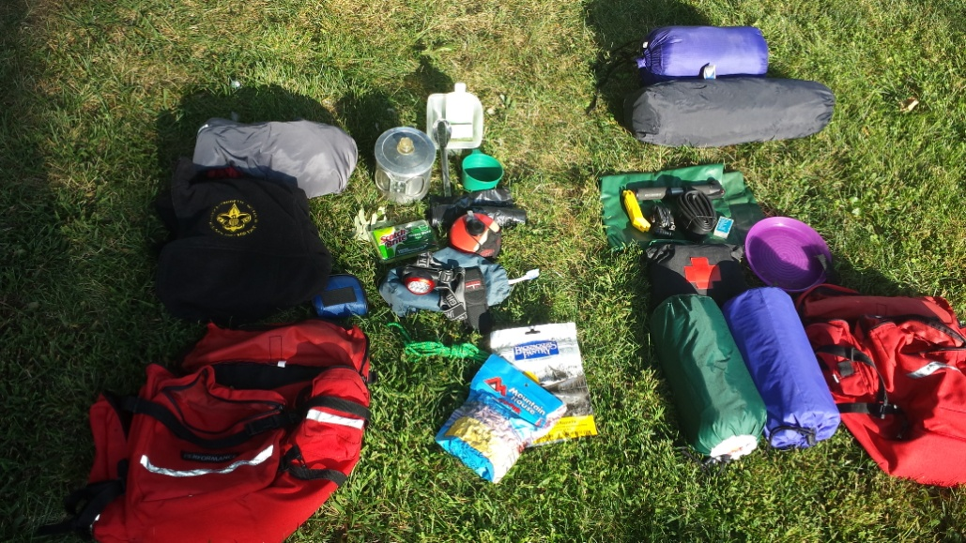
jacket

trash bag

sponge

T128 Fleece

camp towel

toilet kit

headlamp cord multi-tool dinner (stew and chocolate mousse!)
sleeping pad

clothes (shirt, pants, briefs, socks, hat)
plate

first aid kit

